

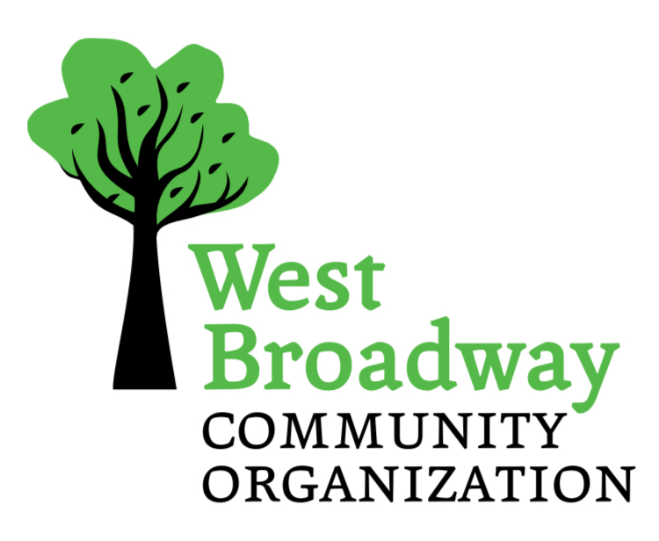

**SMALL GRANTS PROGRAM**

**2025/2026 APPLICATION FORM**

West Broadway Community Organization, in partnership with the Government of Manitoba has established the West Broadway Small Grants Fund, available to groups and organizations in the West Broadway neighbourhood.

Successful grants will:

* Build the social and/or economic capacity of West Broadway
* Emphasize community building / connecting activities
* Have identified support of local residents
* Be submitted by local groups (not individuals)
* Not be used for wages (honorariums excepted)
* Not be used for capital improvements to private property
* Projects involving use of private or public property should have the written permission of the owners or municipality
* Take place within the West Broadway neighbourhood (map available)

|  |  |  |  |
| --- | --- | --- | --- |
| Applicant Organization or Group: | | _________________________________ | |
| Project Name: | | _________________________________ | |
| Grant Amount Requested ($5,000.00 Maximum) | | $ _______________________________ | |
| Total Project Budget: | | $ _______________________________ | |
| Mailing Address: | | _________________________________ | |
| Postal Code: | _____________________ | Fax: | ____________________________ |

Person to contact with questions regarding this application:

|  |  |
| --- | --- |
| Name: | _____________________________________________________________ |
| Phone: | _____________________________________________________________ |
| Email: | _____________________________________________________________ |

2nd Contact Person:

|  |  |
| --- | --- |
| Name: | _____________________________________________________________ |
| Phone: | _____________________________________________________________ |
| Email: | _____________________________________________________________ |

Must be authorized by signing authority from organization/group

|  |  |
| --- | --- |
| Signature: | __________________________________________________________ |
| Date: | __________________________________________________________ |

**APPLICANT PROFILE**

Provide a brief description of your organization or group (who you are, what is your focus/mission, etc.). (100 words maximum)

**PROJECT DESCRIPTION**

1. Provide a brief description (200 words maximum) of the project including:
   1. What is the purpose / goal:
   2. Description of project activities:
2. Briefly describe how the project will be accomplished and by whom?
   1. Identify organizations involved
   2. Number of volunteers to be involved
   3. Number of West Broadway residents who will be part of the planning and implementation of the project
3. How will this project build community, build local capacity and connect community members? (100 words maximum)
4. Please describe expected results and the timeline needed to develop and complete the project. (100 words maximum)
5. Does the project utilize private or public property? No: ________ Yes: ________ (If yes, please attach written permission including address)
6. Expected Starting Date of this project: __________________________________
7. Expected Completion Date of this project: _______________________________ Projects must be complete, and reports submitted no later than March 15, 2026
8. How have you identified the support of local residents for this project? (Feel free to attach a maximum of two emails or letters of support if needed)
9. How many West Broadway residents will be impacted by this project?
10. What is the total cost of the project? Are you leveraging other sources of funding? If so from where? Applicants must attach a detailed budget (including income and expenses). If your project involves capital expenditures, please provide TWO quotes or evidence to back up your expenses.