

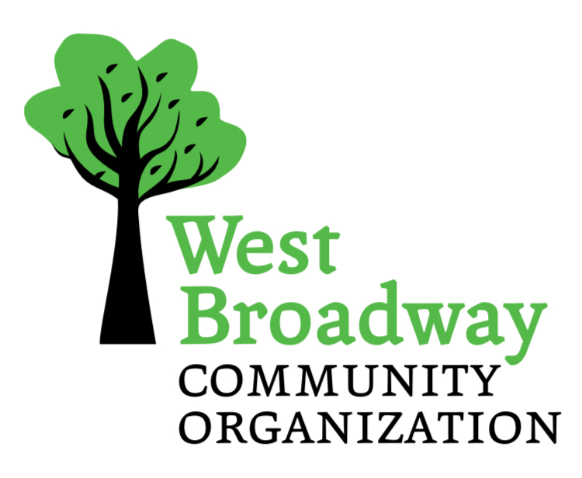

West Broadway Community Organization

748 Broadway, Winnipeg, MB R3G 0X3

Phone (204) 774-7201

**SMALL GRANTS FUND**

**Project Report / Evaluation 2025-2026**

ORGANIZATION/GROUP NAME: __________________________________________

PROJECT NAME: _______________________________________________________

1. Was this a new project or is it recurring? ________________________________
2. Project Start Date __________________ End Date _______________________
3. What was the purpose/ goal of the project (maximum two sentences):
4. Briefly describe the activities that took place (maximum 100 words):
5. How many West Broadway residents participated? (Please list the exact number or your best estimate) ______________________________________________

* 1. How many were assisting as volunteers? __________________________

1. Did you have partnerships with other groups or organizations? If so, please name them.
2. Briefly describe the outcomes of the project. How has the community benefited? (maximum 100 words)
3. What was your total project cost? _____________________________________
4. Did your project leverage funding from another source? If so, how much and from whom?
5. Please submit a financial reporting sheet with photocopies of all paid invoices and receipts. All Small Grant money must be accounted for.

SIGNATURE: __________________________________________________________

DATE: ________________________________________________________________