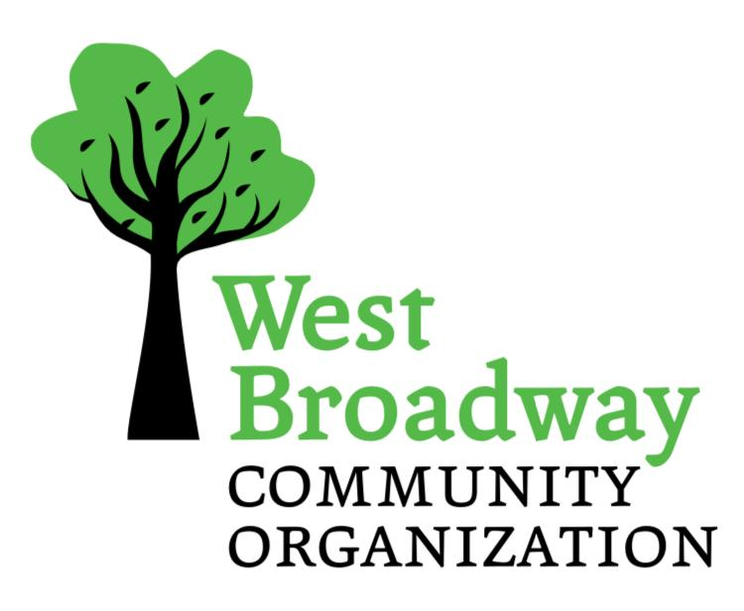
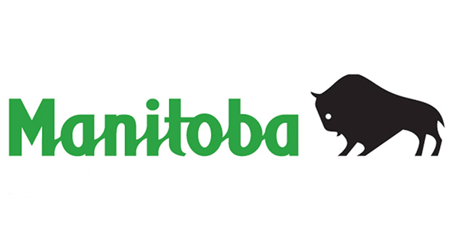

West Broadway Community Organization
748 Broadway, Winnipeg, MB R3G 0X3
Phone (204) 774-7201

SMALL GRANTS FUND
Project Report / Evaluation 2026-2027

ORGANIZATION/GROUP NAME: __________________________________________

PROJECT NAME: ______________________________________________________

- Was this a new project or is it recurring? _______________________________

- Project Start Date __________________ End Date ______________________

- What was the purpose/ goal of the project (maximum two sentences):

- Briefly describe the activities that took place (maximum 100 words):

- How many West Broadway residents participated? (Please list the exact number or your best estimate) ______________________________________________

  - How many were assisting as volunteers? _________________________

- Did you have partnerships with other groups or organizations? If so, please name them.

- Briefly describe the outcomes of the project. How has the community benefited? (maximum 100 words)

- What was your total project cost? _____________________________________

- Did your project leverage funding from another source? If so, how much and from whom?

- Please submit a financial reporting sheet with photocopies of all paid invoices and receipts. All Small Grant money must be accounted for.

SIGNATURE: _________________________________________________________
DATE: _______________________________________________________________

